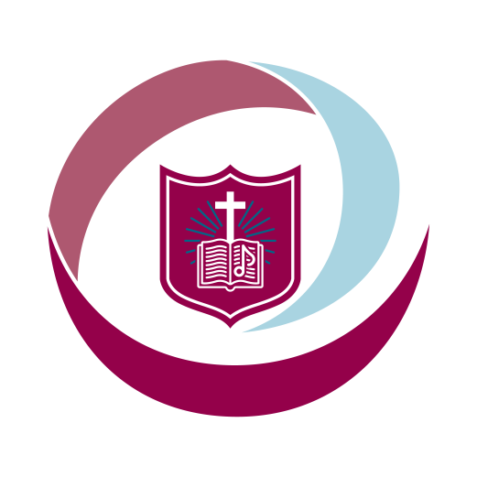 St Gregory’s Catholic Primary School
Loving and Learning
Newsletter 2 26th October 2023
This half-term we are Grateful and Generous.
New Governors
Our governors play a very important role in the life of our school. It is the Local Governing Board who ensure that your children are safe and receiving the high standard of education that they are entitled to. They hold me and all the other staff to account and act as our ‘critical friends’. The role is time-consuming, carries great responsibility and is purely voluntary. I can speak for all the staff when I say that we are immensely grateful for the hard work carried out by our governors.
I am delighted to announce that we have two new governors who will be joining us after half-term. They are Ms Tracey Walton (mother of Evan), who is a new parent governor, and Mr Bernard Walsh, who is a new foundation governor. We welcome Ms Walton and Mr Walsh to the Local Governing Board and look forward to working with them.
PTA Cake Sale and Pre-Loved Uniform Sale
Another group of volunteers who play a vital part are our PTA. They will be holding a Cake and Pre-Loved Uniform Sale tomorrow after school. All the money raised will be used to enhance the education of our pupils. Please come along and support the PTA and, if you have the time, consider joining; everyone is welcome.
CAFOD Harvest Assembly
Today, we had a special assembly led by Brian, a volunteer with CAFOD. Brian came to talk to the children about the work that CAFOD does in various parts of the world. I was very pleased when he said that he had never seen pupils come into an assembly so quietly and sensibly (but I would expect nothing less from St Gregory’s pupils). In addition, he was impressed with the children’s thoughtful answers. You should be extremely proud of your children.
Thank you for your generosity in supporting CAFOD’s work today. Our ‘Mini Vinnies’ from Year 5 will decide how we use the money that we have raised; they will choose from CAFOD’s ‘World Gifts’ such as essential medical supplies, supporting a child’s education or even buying a goat for a family!
It was lovely to see children in their own clothes, even those who were wearing West Bromwich Albion shirts (but at least it wasn’t Birmingham City...).

Parish News
Fr Cownley’s Requiem Mass was a very moving occasion, and it was an honour to represent the school in my role as a deacon. Monsignor Tim Menzies has kindly agreed to my invitation to celebrate Mass at school in memory of Fr Cownley; this is being arranged for after half term and I will provide further details when I have them. The former Prayer Garden is going to be renovated to become a memorial for both Fr Cownley and Mr Hogan (whose memorial we had to remove for safety reasons in the Summer holidays).
Fr Lennon is currently unable to say Mass at school. In his absence, I will continue to lead Services of The Word.
During the half term break, I will be meeting with Bishop David Evans, the Dean and representatives from the parish to look at ways forward for the parish and the school. There is a vibrant and active Catholic community in Bearwood, and it is important that it continues to grow.
Please can you pray for:
The soul of Fr Cownley and his family and friends; Fr Lennon; all those far from home and loved ones; those in our community who are suffering in any way; peace, especially in Ukraine and Israel/Palestine.

On behalf of all the staff, can I express our thanks for your continued support. During the Sacrament of Baptism, we parents are reminded that we are the ‘first educators’ of our children; education is a partnership between home, school and parish and at St Gregory’s, we want to make that partnership ever stronger. We hope that you and your families have a lovely, relaxing break and we look forward to seeing you on Monday 6th November.
Rev Mark Paine
Principal

Masses at Our Lady of Good Counsel and St Gregory the Great are at:
5pm (Saturday Vigil); 9 am and 11 am on Sundays.

“Peace among men is an essential good for which we must work zealously and fervently beseech God. Every war leaves the world worse off than it found it.” (Pope Francis)

